Create a simple cloud software application for Payroll Processing System using any Cloud Service Provider to demonstrate SaaS include the necessary fields such as Name of the employee, experience in present org , over all experience, basic pay, HRA, DA, TA, net pay, gross pay etc.

Step1: Creating a simple Software application for payroll processing system using Cloud Services.

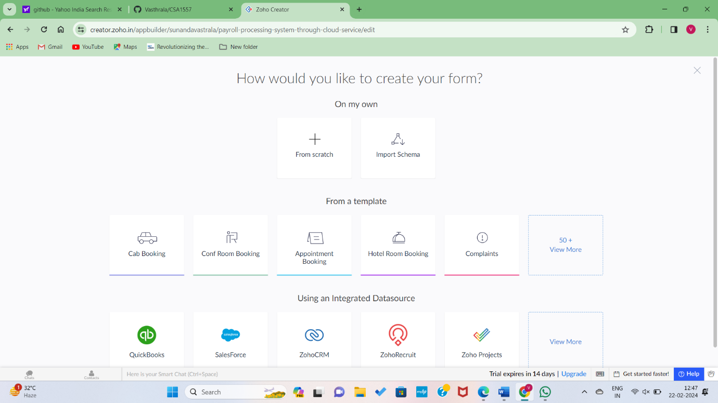

Step2: Creating an application using scratch.

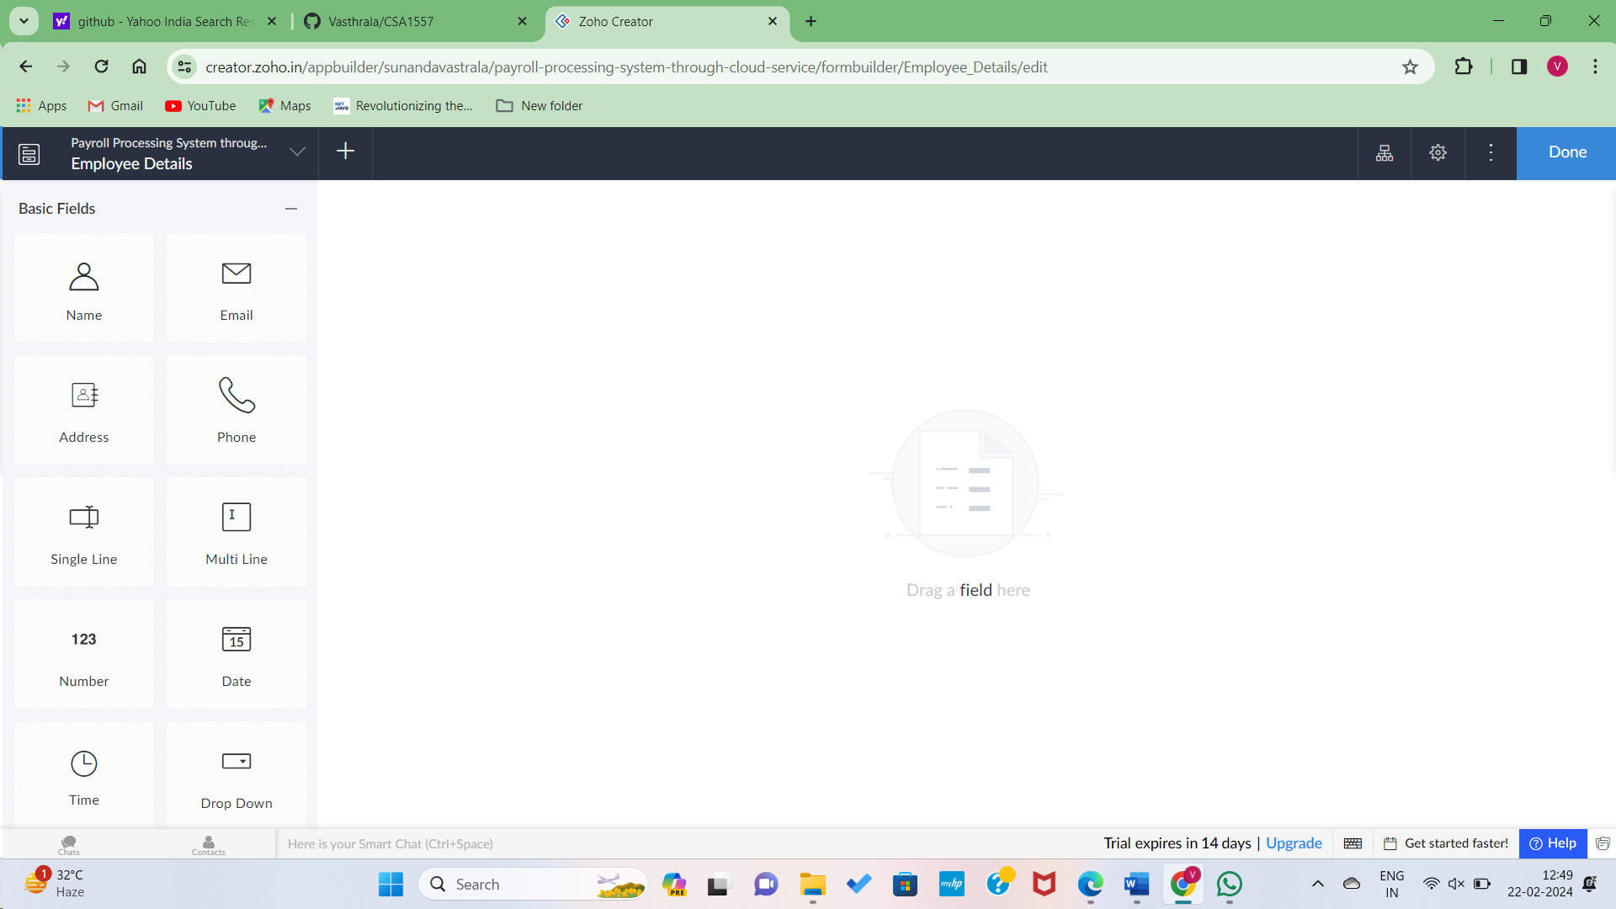

Step3: Dragging all the user or employee details regarding payroll process.

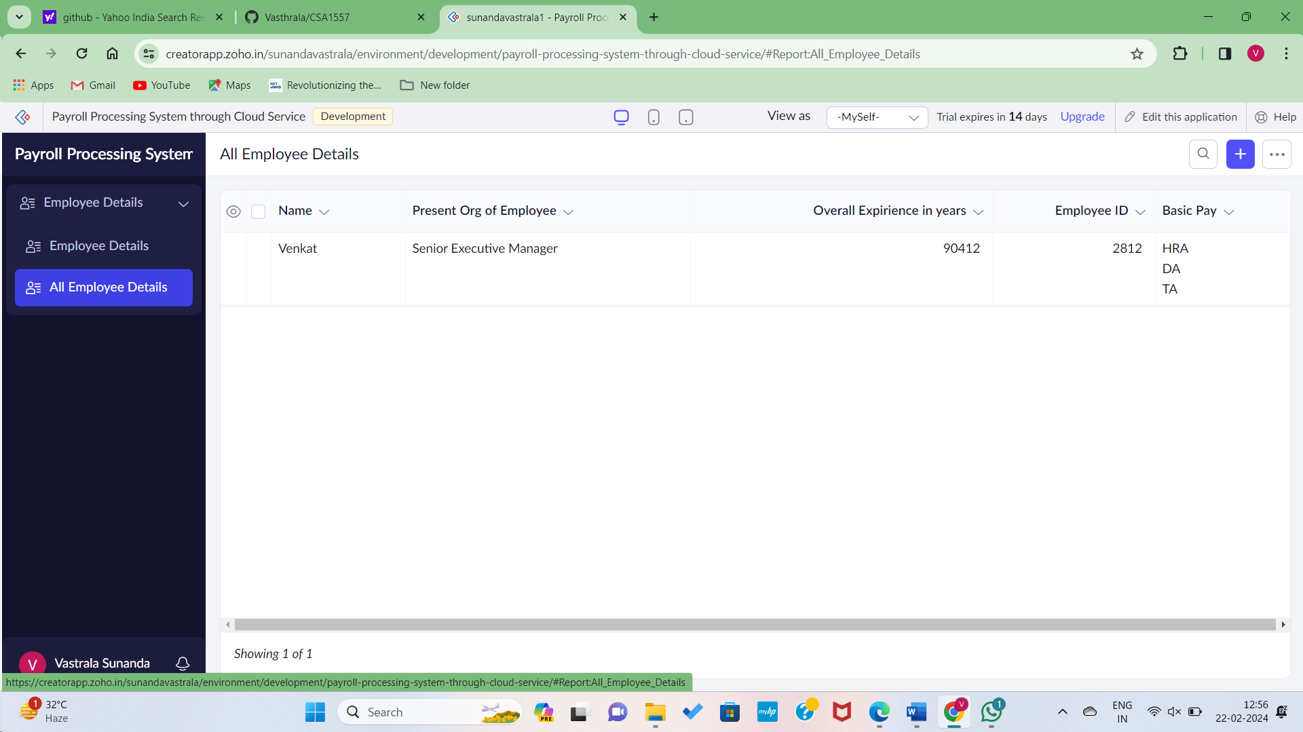

Step4: Creating another form for Backened development on employee details.

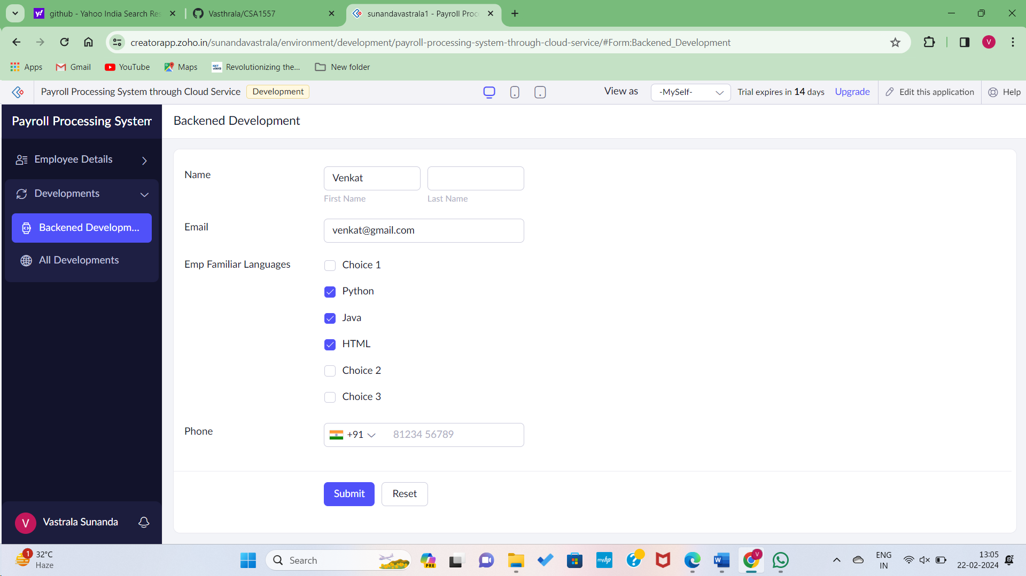

Step5: Data Adding to the Server of the application.

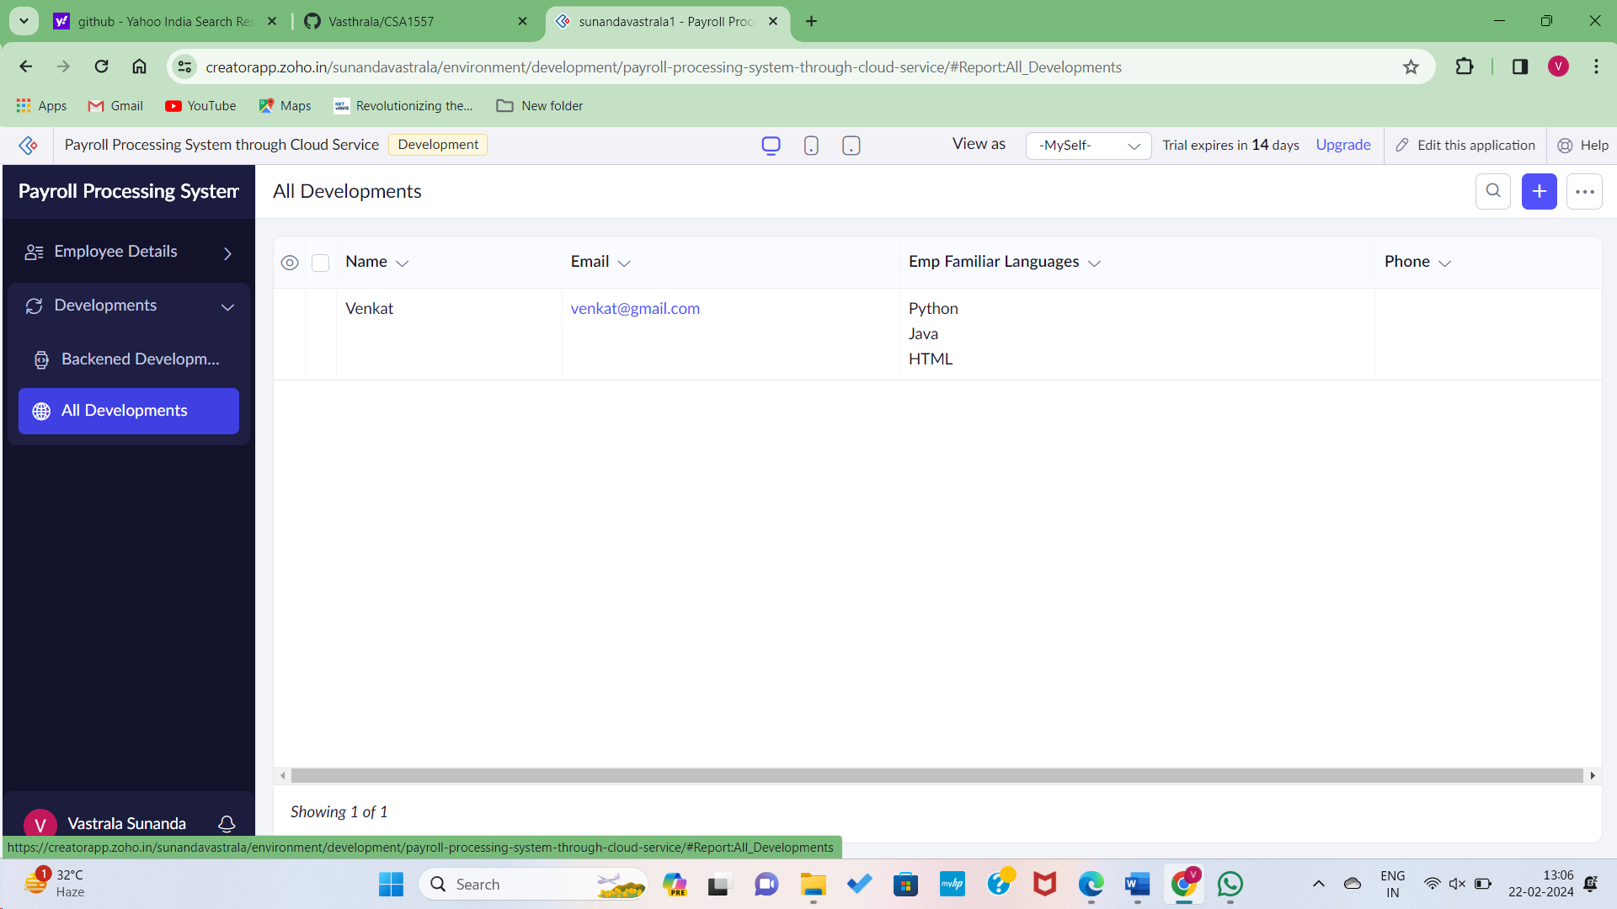

Step6: Database setup of the employee salary details.

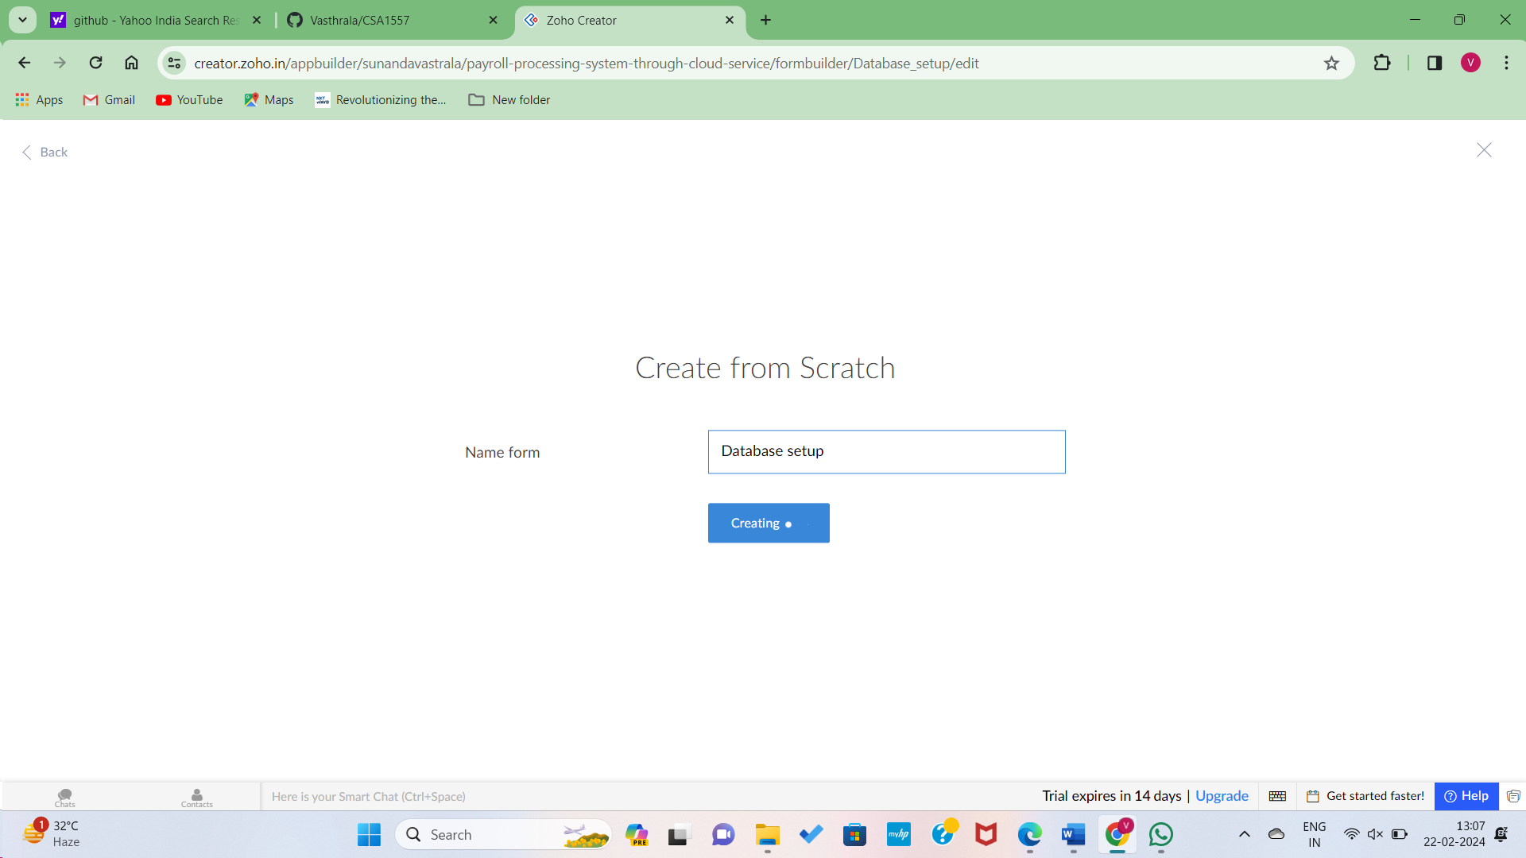

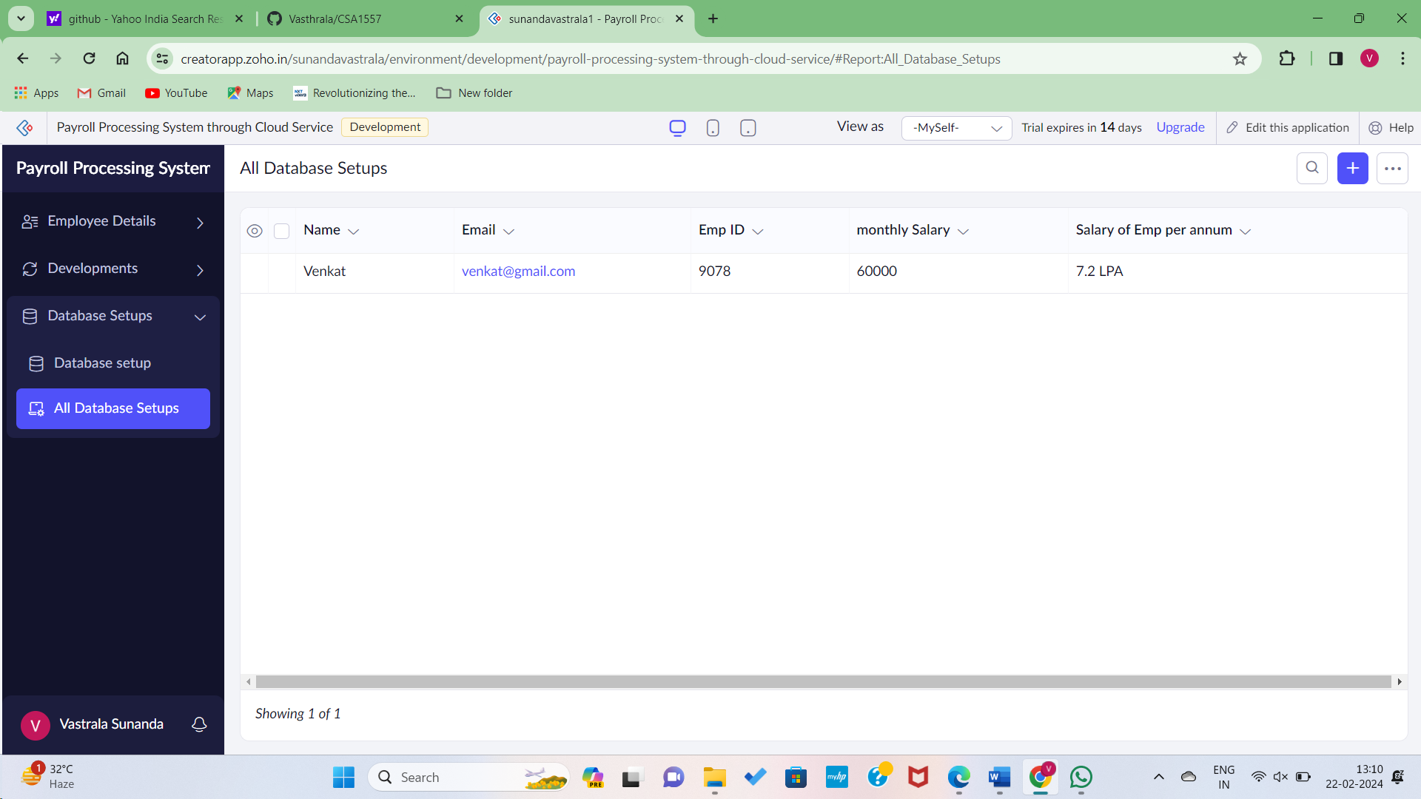

Step7: Hence the Employee payroll processing through cloud services created successfully..